1) Create a table name STUDENT with following structure.

 | Column
S.nO | Name | Description | Data Type
 |  | Registration
1 | RegNo | Number | NUMBER(3)
2 | Name | Student Name | VARCHAR(15)
 |  | Gender of the
3 | Gender | student | CHAR(1)
4 | DOB | Date of Birth | DATE
5 | MobileNo | Mobile Number | NUMBER(10)
6 | City | Location of stay | VARCHAR(15)

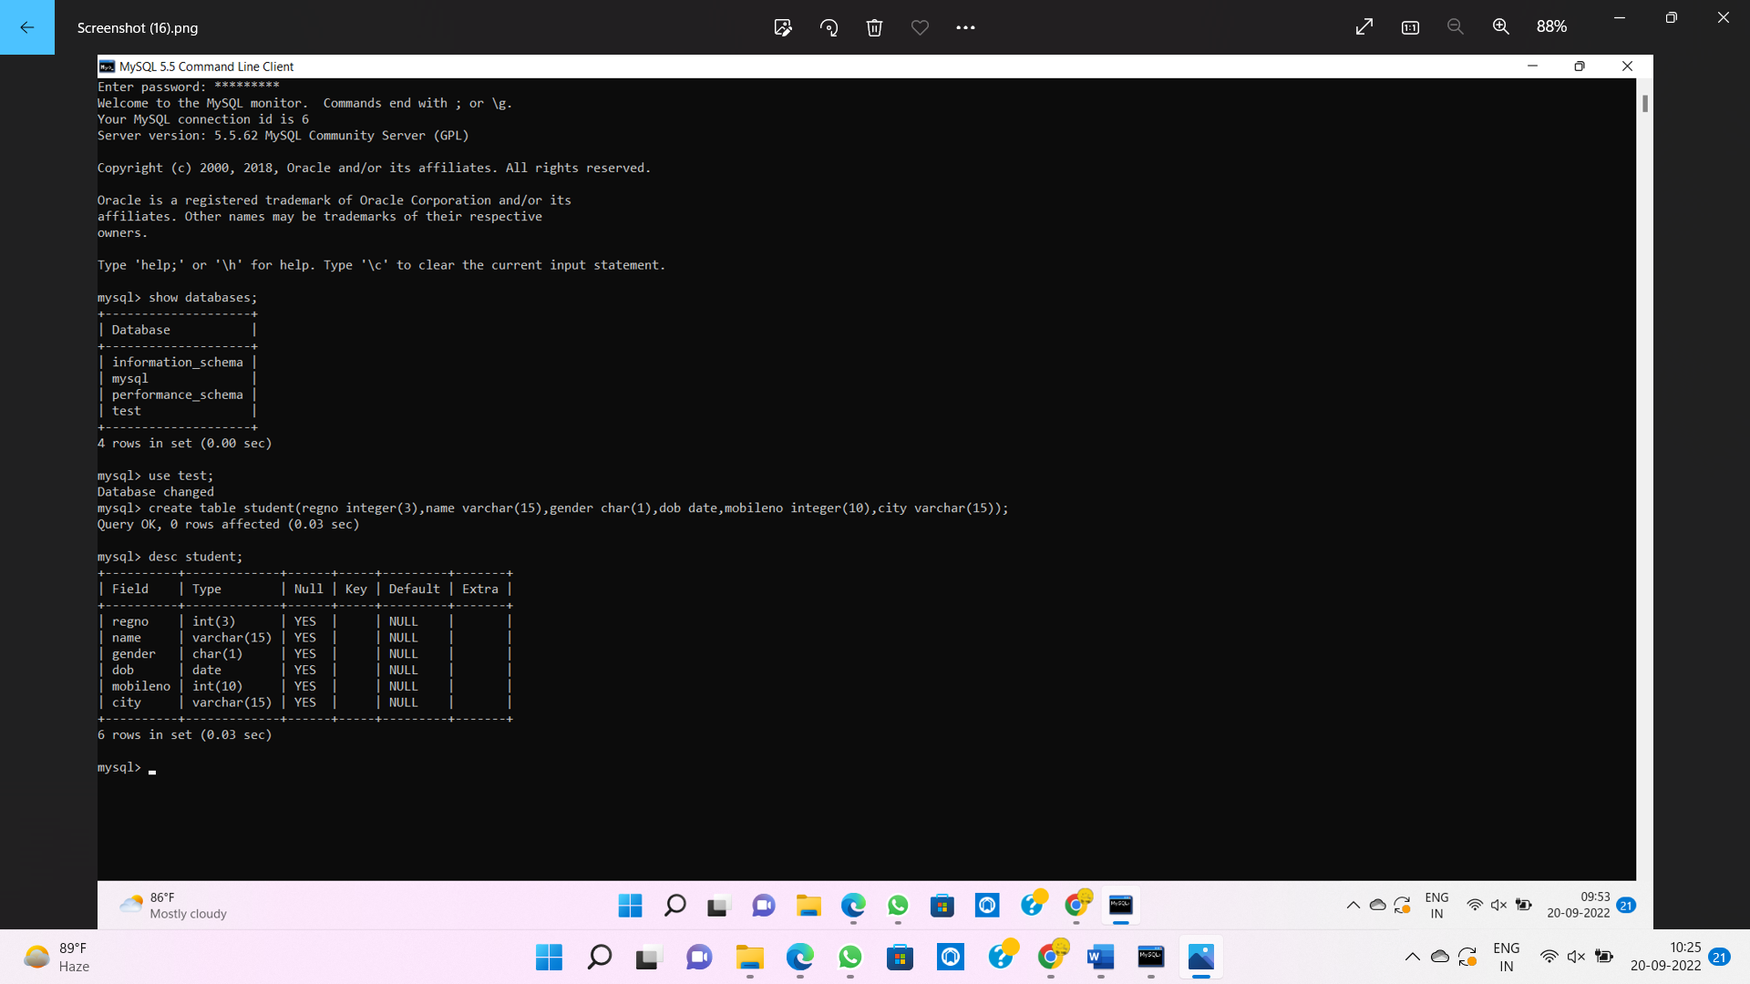

2) Create a table name FACULTY with following structure.

 | Column
S.nO | Name | Description | Data Type
1 | FacNo | Faculty Identifier | VARCHAR(4)
2 | FacName | Faculty Name | VARCHAR(15)
3 | Gender | Gender of faculty | CHAR(1)
4 | DOB | Date of Birth | DATE
5 | DOJ | Date of Join | DATE
6 | MobileNo | Mobile Number | NUMBER(10)
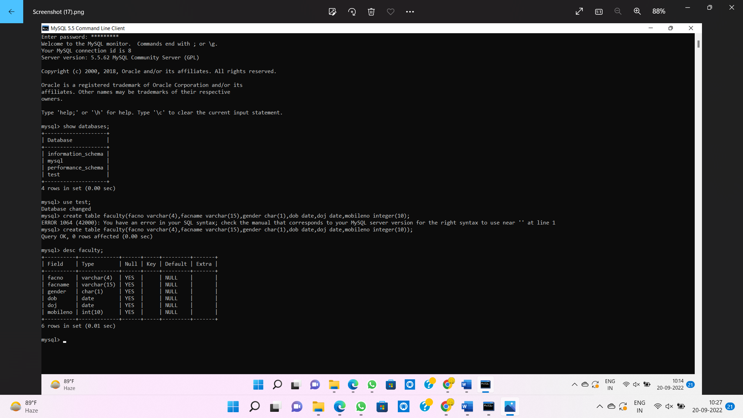

3) Create a table name DEPARTMENT with following structure.

 | Column
S.nO | Name | Description | Data Type
1 | DeptNo | Department Identifier | VARCHAR(4)
2 | DeptName | Department Name | VARCHAR(15)
3 | DeptHead | Department Head | VARCHAR(4)

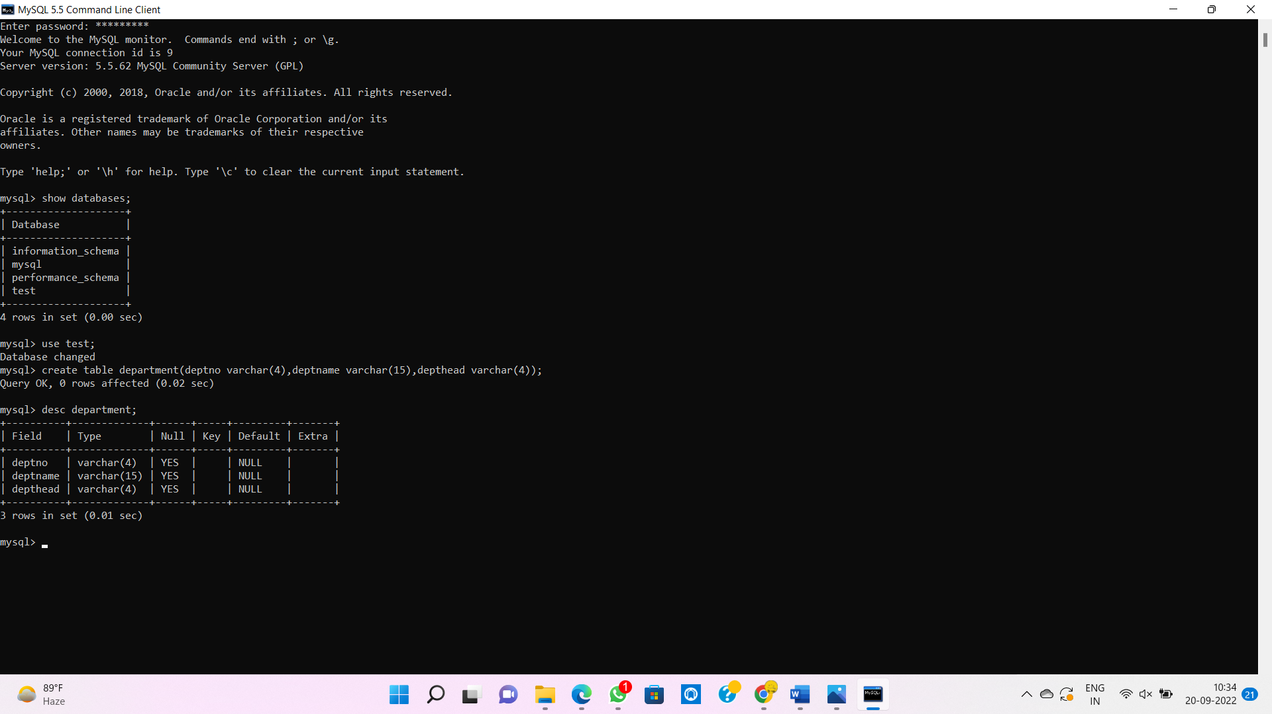

4) Create a table name COURSE with following structure.

 | Column
S.nO | Name | Description | Data Type
1 | CourseNo | Course Identifier | VARCHAR(3)
 |  | Course
2 | CourseDesc | Description | VARCHAR(14)
3 | CourseType | Course Type | CHAR(1)
4 | SemNo | Semester Number | CHAR(1)
5 | HallNo | Hall Number | VARCHAR(4)
6 | FacNo | Faculty Identifier | VARCHAR(4)
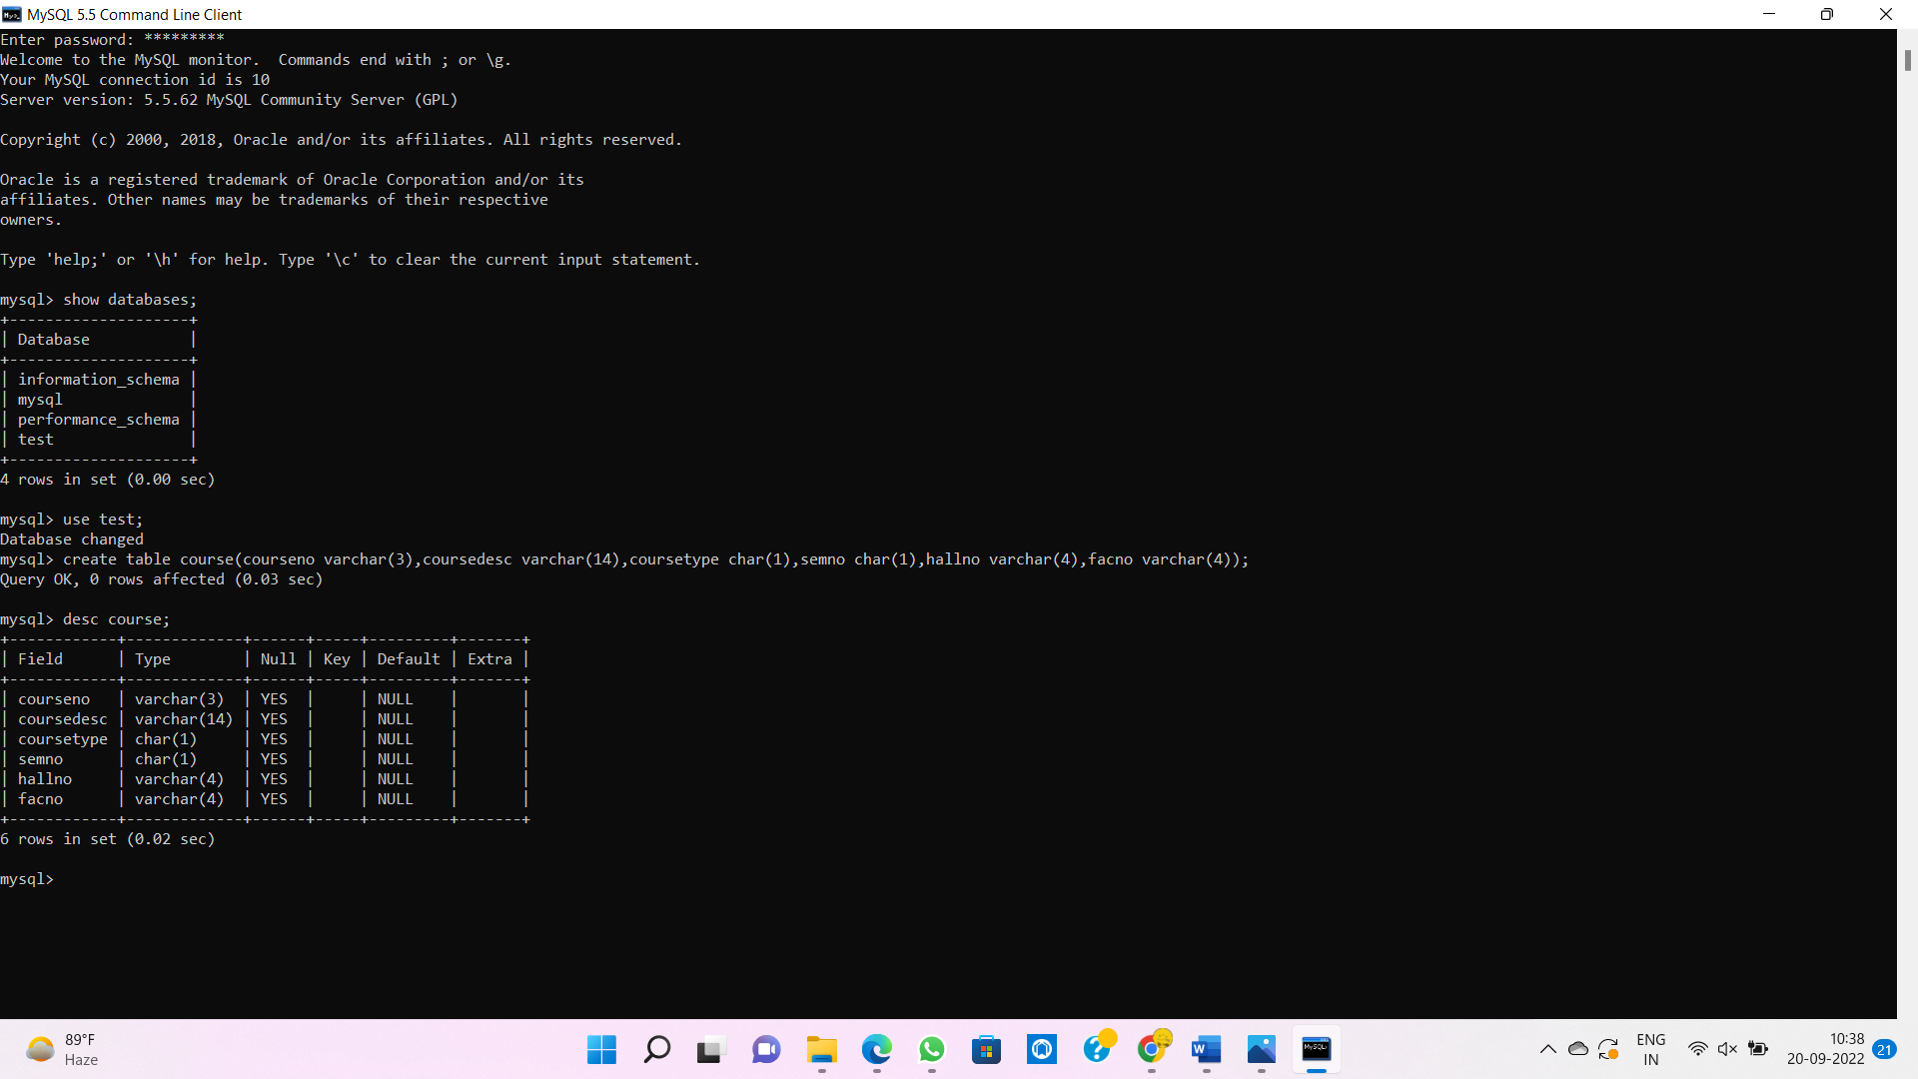

- Modify the table FACULTY by adding a column name DeptNo of datatype VARCHAR(4)
